**INSTALLED KUBERNETES USING MINIKUBE**

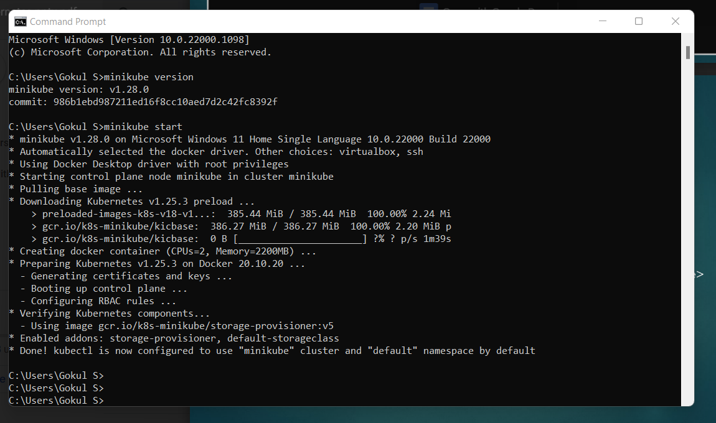

**DOCKER COMPOSE WITH PYTHON AND MYSQL**

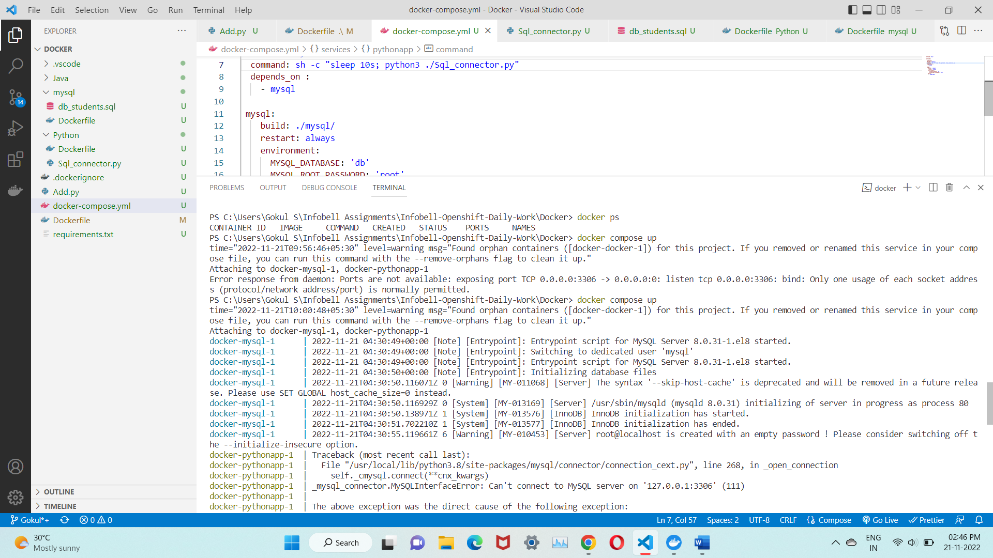

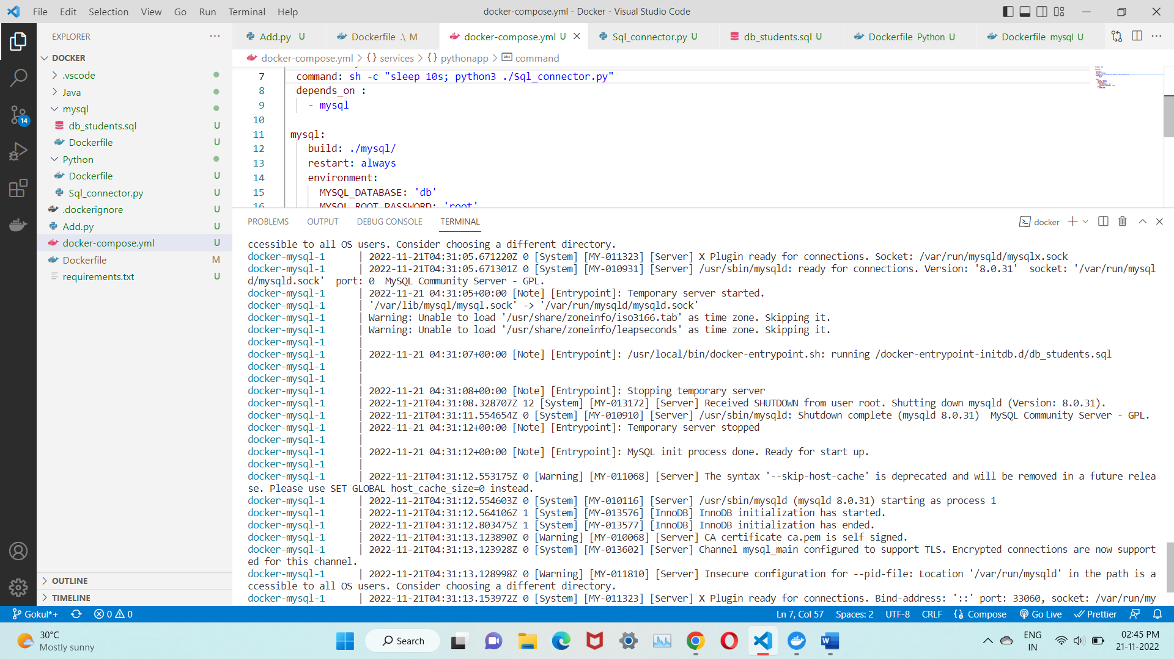

**KUBECTL COMMANDS**

